Grade 8 ELA
Year-at-a-Glance (DRAFT)
2024-2025
Module A    August 12-September 13  24 Days | Pivotal Moments  Essential Question: How do life’s unexpected turns influence the dynamics of different relationships?  Reading Focus: Drums, Girls, and Dangerous Pie, “I’m Nobody! Who Are You?” StudySync, “Blind” StudySync  Writing Focus: Personal Narrative, Shared Experience Writing (Narrative) | Focus Benchmarks  ELA.8.R.1.1  ELA.8.R.1.2  ELA.8.R.1.3  ELA.8.R.1.4  ELA.8.R.3.1  ELA.8.R.3.3  ELA.8.C.1.2
Module B  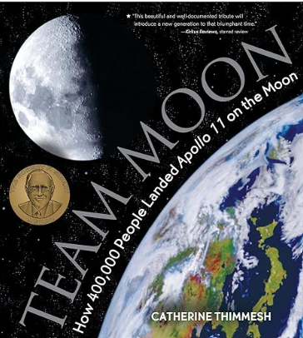  September 16-October 11  19 Days | To Infinity and Beyond  Essential Question: How does space exploration shape our understanding of the universe and our role within it?  Reading Focus: Team Moon BEST, “Address to the Nation on the Explosion of the Space Shuttle Challenger” StudySync, “Spaceships” StudySync, excerpt from The War of the Worlds StudySync, “Space X and Blue Origins”, “Advancing the Cosmos”  Writing Focus: Argumentative | Focus Benchmarks  ELA.8.R.1.4  ELA.8.R.2.1  ELA.8.R.2.2  ELA.8.R.2.3  ELA.8.R.2.4  ELA.8.R.3.1  ELA.8.C.1.3
Module C    October 15-November 8  19 Days | The Twilight Zone  Essential Question: When people encounter strange or mysterious situations, how do they navigate through these experiences?  Reading Focus: “How the Twilight Zone Predicted our Paranoid Present”, "The Raven” BEST, “Let ‘Em Play God” StudySync, “Ten Days in a Madhouse” StudySync, “The Lottery” StudySync, “The Monkey’s Paw” StudySync, “Phineas Gage” StudySync, “There Will Come Soft Rain” StudySync  Writing Focus: Expository  DISTRICT WRITING ASSESSMENT – Week of November 4 | Focus Benchmarks  ELA.8.R.1.1  ELA.8.R.1.2  ELA.8.R.1.4  ELA.8.R.2.1  ELA.8.R.2.3  ELA.8.R.2.4  ELA.8.R.3.3  ELA.8.C.1.4
Module D    November 11-December 20  24 Days | Identity, Conflict, & Society  Essential Question: How do societal labels and stereotypes influence individual identity and behavior?  Reading Focus: The Outsiders, “We Real Cool” BEST, “Nothing Gold Can Stay”, “O Captain, My Captain”, “Herd Behavior”, “Healing ‘Brick City’: A Newark Doctor Returns Home”  Writing Focus: Argument/Expository | Focus Benchmarks  ELA.8.R.1.1  ELA.8.R.1.2  ELA.8.R.1.3  ELA.8.R.1.4  ELA.8.R.2.2  ELA.8.R.3.1  ELA.8.R.3.3  ELA.8.R.3.4  ELA.8.C.1.3  ELA.8.C.1.4
Module E    January 7 – February 7  23 Days | Facing Adversity  Essential Question: How do individuals harness resilience and adaptability to navigate and overcome adversity in their lives?  Reading Focus: Diary of Anne Frank – The Play, “A Day Which Will Live in Infamy” BEST, “Nobel Prize Acceptance Speech – Elie Wiesel” StudySync, “Parallel Journeys” StudySync, excerpt from – Hitler’s Youth: Growing Up in Hitler’s Shadow – StudySync  Writing Focus: Expository | Focus Benchmarks  ELA.8.R.1.1  ELA.8.R.1.2  ELA.8.R.1.3  ELA.8.R.2.1  ELA.8.R.2.2  ELA.8.R.2.3  ELA.8.R.2.4  ELA.8.R.3.4  ELA.8.C.1.4
Module F  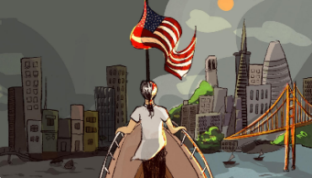February 10 – March 14  24 Days | Chasing the American Dream  Essential Question: What defines the American Dream and how does it shape individual aspirations, societal values, and opportunities for success?  Reading Focus: “What Does American Democracy Mean to Me?” StudySync/BEST, “9/11 Address to the Nation” BEST, “Inside Out & Back Again” StudySync, “America” StudySync, “To America” StudySync, “The House on Mango Street” StudySync, “Ain’t I a Woman” BEST, Immigration: Was It Worth It? Text Set  Writing Focus: Argument | Focus Benchmarks  ELA.8.R.1.2  ELA.8.R.1.4  ELA.8.R.2.1  ELA.8.R.2.2  ELA.8.R.2.3  ELA.8.R.2.4  ELA.8.R.3.3  ELA.8.R.3.4  ELA.8.C.1.3
Module G  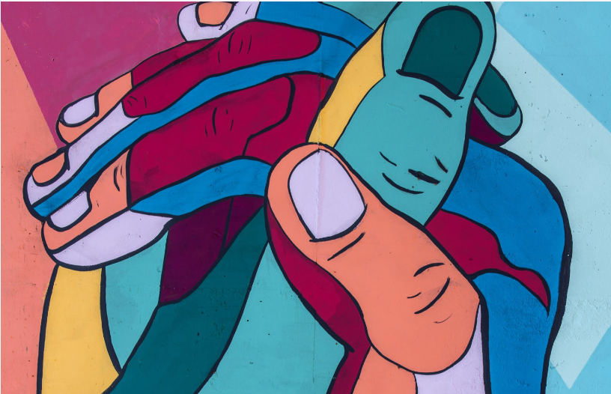  March 24 – April 25  23 Days | Power of Connection  Essential Question: How can we adapt our social connections to influence and support each other?  Reading Focus: excerpt from Trapped BEST, Hephaestus passage set, “The Gift of the Maji” StudySync/BEST, “Gaming Communities” StudySync  Writing Focus: Expository/Argumentative | Focus Benchmarks  ELA.8.R.1.1  ELA.8.R.1.2  ELA.8.R.2.1  ELA.8.R.2.2  ELA.8.R.2.3  ELA.8.R.2.4  ELA.8.R.3.1  ELA.8.R.3.2  ELA.8.R.3.3  ELA.8.C.1.3  ELA.8.C.1.4
Module H  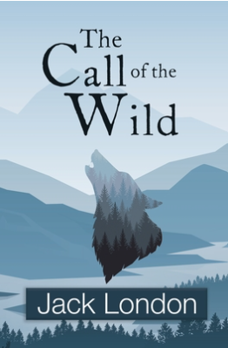  April 28 – May 29  23 Days | The Great Unknown  Floating Five: Strategic Reading Days (prior to FAST PM 3)  Essential Question: What insights can be gained from the adventures of individuals as they navigate into the unknown?  Reading Focus: A First Time for Everything (graphic novel), excerpt from The Call of the Wild StudySync/BEST, excerpt from The Hobbit StudySync/ BEST, “The Road Not Taken” StudySync/BEST, The Wright Brothers BEST, excerpt from Swiss Family Robinson BEST, excerpt from The Adventures of Tom Sawyer - StudySync  Writing Focus: Personal Narrative, Shared Experience Writing (Narrative) | Focus Benchmarks  ELA.8.R.1.1  ELA.8.R.1.2  ELA.8.R.1.3  ELA.8.R.1.4  ELA.8.R.2.1  ELA.8.R.2.2  ELA.8.R.2.3  ELA.8.R.2.4  ELA.8.R.3.1  ELA.8.R.3.3  ELA.8.R.3.4  ELA.8.C.1.2
*Benchmarks ELA.8.V.1.2, ELA.8.V.1.3, and ELA.8.R.3.2 are embedded in each module.

